Journalists on Film - The Quest for Truth
By RICH EGGER • FEB 13, 2020
ShareTweetEmail
- 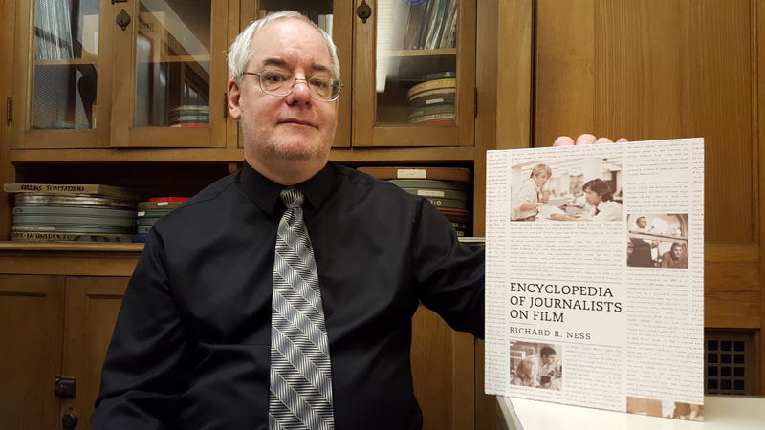
Richard Ness in his office in WIU's Simpkins Hall
Richard Ness wrote a book about journalism movies around 20 years, and in recent years he started work on a second edition. He said the first edition analyzed more than 2,000 films, and he was up to around 4,500 films for the second edition when the publisher stepped in and suggested he scale it back.
“We decided to focus on the key films that somebody wanting to learn about journalists in movies would look at,” said Ness, who is a professor of film studies in the Department of English at Western Illinois University.
“So we narrowed down the 4,500 films to about 500 that we felt were the ones that really dealt with journalism issues.”
The result is “Encyclopedia of Journalists on Film.”
Listen
4:50
Listen to the radio interview
Ness said the book includes entries about the basics, such as “Citizen Kane,” “All the President’s Men,” and “Spotlight.” But he said it delves deeper than that.
“I also tried to put in some films that maybe people wouldn’t necessarily think of immediately but either represent trends in journalism films or represented maybe things from another culture or another country that kind of showed the universality of how journalism is treated,” he said.
He said journalists seem to be represented in all genres of film. He believes that’s because so many plots include a quest for truth.
“I think it represents this value of our society that we want the truth eventually to come out. We’re living through it right now. We’re seeing it play out on television today,” Ness said.
“And there are a lot of attempts to manipulate it or to gloss it over or to disguise it or hide it, but eventually it seems like it emerges. And journalists I think are key to accomplishing that.”
Ness said the book lists the films in alphabetical order, like an encyclopedia. He said the earlier book listed films in chronological order and included entries about films with journalists no matter how large or small the character’s role.
Ness also recently wrote an article about India remakes of Frank Capra films. It was published by The Image of the Journalist in Popular Culture, which is a project of The Norman Lear Center at the USC Annenberg School for Communication and Journalism.

